**Machine Learning Engineer Nanodegree**

**Capstone Project**

Sourish Banerjee  
May 1st, 2018

**I. Definition**

**Project Overview**

Steganography is the art of hiding messages in images by altering the least significant bits of the pixels in images with that of the message bits. The result is an image with a message hidden in it. However, the change is imperceptible to the human eye. This is because on changing the least significant bits in the pixels of an image, the pixel values are only altered by a small amount, resulting in a visually similar altered or steg image obtained from the original or cover image. Steganography has been widely used because of its potential capability to hide the existence of sensitive data. In situations where this kind of data hiding is illegal, potentially dangerous or inherently unethical, it becomes necessary to detect the presence of steganography in images.

Steganalysis is the art of detection of steganography in an image. There are two major types of steganography, and the preferred steganalysis methods for them are also different [1]. The naïve method is called LSB replacement. In this method, the LSB bit remains unchanged if the message bit is the same as the LSB bit, otherwise, the bit is altered. Hence, the odd pixels are reduced by 1 in intensity, whereas the even pixel values are incremented by 1. However, this causes an imbalance in the image histogram, which can be easily exploited by statistical methods for steganalysis. The second method of LSB steganography, LSB matching solves this issue by randomly incrementing or decrementing the pixel values by 1 in case of an LSB bit mismatch. This avoids the issue of histogram imbalance and makes it difficult to perform steganalysis by statistical methods alone.

In this project, I have implemented a detector for presence of LSB matching in greyscale images using classification techniques. Over the years, several feature sets have been proposed for the purpose of training, including HCFHOM [2], A. HCFCOM, C.A. HCFCOM [3] and HOMMS [4]. In this project, I have used the CF feature set proposed in [5] on the BOSSbase dataset. The implementation involves feature extraction from 20000 images (10000 cover and 10000 steg images with a payload of 0.4), training of classifiers on the resultant feature dataset, persisting of the models having the best performance, and building of a detector using a voting ensemble of these classifiers. The code for the feature extraction is available in the 'Image Preprocessing.ipynb' notebook. The original BOSSbase dataset has 10,000 greyscale images, each of size 512 x 512. All the images in the dataset are treated as the cover images. From this dataset, I have generated 10,000 corresponding images corrupted with LSB matching steganography with a payload of 0.40 (payload refers to the fraction of pixels in the original image that has been corrupted due to the steganography process). For this purpose, I have used the tool available in [6]. The tool to generate the steg images is as follows:

$ python aletheia.py lsbm-sim bossbase 0.40 bossbase_lsb

**Problem Statement**

The main goal is to classify greyscale images based on whether they are corrupted with LSB matching or not. I have used a labelled dataset of greyscale images, both with and without LSB matching and have developed a supervised learning workflow to solve this problem. The final result of the project is a tool that takes as input any grayscale image and gives a prediction as to whether the image is corrupted with LSB matching or not. The project workflow is detailed in brief under the project overview.

**Metrics**

I have used the F-Score as an evaluation metric for the benchmark and solution model. The F-Score is defined as the harmonic mean over precision and recall for a given test. Precision is the number of correct positive results (True Positives) divided by the number of all positive results returned by the classifier (True Positives + False Positives), and recall is the number of correct positive results True Positives) divided by the number of all samples that should have been identified as positive (True Positives + False Negatives). The above metrics are formalized as follows:

Precision = TP / (TP + FP)

Recall = TP / (TP + FN)

F-Score = (2 * Precision * Recall) / (Precision + Recall)

The F-Score is a good metric for the problem as applications of steganalysis require both good precision and recall. For example, in a naive use case where all detected cases of steganography are penalized, we would like to detect as many true cases as possible (high recall) while at the same time trying to prevent false positives and hence unjust penalties (high precision).

**II. Analysis**

**Data Exploration**

I Unlike that in LSB embedding, the imbalances caused by LSB matching in the spatial domain are not obvious enough to be exploited by statistical techniques alone. The CF feature set [5] comprises of 41 features and is based on the premise that given enough spatial information to train on, learners will eventually be able to pick up these subtler imbalances. Because LSB matching primarily alters the spatial data in the Least Significant Bit Plane (LSBP) and the Second Least Significant Bit Plane (LSBP2), the feature set mostly focuses the spatial information in these bit planes. Quantifying the correlation between bit planes and auto correlation within a bit plane are good ways of capturing such spatial information. This is the primary technique used in the CF feature set. It also captures the correlation between various slices of the image histogram in its density form, as well as the autocorrelations between the noise in the LSBP, which is obtained by subtracting the original image from various denoised images. These denoised image are in turn obtained via the removal of low complexity features from the Haar transform of the image using several different thresholding values.

Following are the formal expressions for each of the 41 features in the CF feature set:

M1 (1: m, 1: n) denotes the binary bits of LSBP and M2 (1: m, 1: n) denotes the binary bits of LSBP2.

C 1 = cor (M1, M2)

The autocorrelation of LSBP, C (k, l), is defined as:

C (k, l) = cor (Xk, Xl)

where,

Xk = M1(1: m – k, 1: n – l) and Xl = M1 (k + 1: m, l + 1: n)

Different values are set to k and l, and C2 to C15 is defined as:

C2 = C (1, 0); C3 = C (2, 0); C4 = C (3, 0);

C5 = C (4, 0); C6 = C (0, 1); C7 = C (0, 2);

C8 = C (0, 3); C9 = C (0, 4); C10 = C (1, 1);

C11 = C (2, 2); C12 = C (3, 3); C13 = C (4, 4);

C14 = C (1, 2); C15 = C (2, 1).

The histogram probability density, H, is denoted as (ρ0, ρ1, ρ2 …ρN-1). The histogram probability densities, He, Ho, Hl1, and Hl2 are denoted as follows:

He = (ρ0, ρ2, ρ4 …ρN-2), Ho = (ρ1, ρ3, ρ5 …ρN-1);

Hl1 = (ρ0, ρ1, ρ2 …ρN-1-l), Hl2 = (ρl, ρl+1, ρl+2 …ρN-1).

The autocorrelation coefficients C16 and CH(l) are defined as follows:

C16 = cor (He, Ho)

CH (l) = cor (Hl1, Hl2)

The features from C17 to C20 are defined as follows:

C17 = CH (1), C18 = CH (2),

C19 = CH (3), C20=CH (4).

Besides the features mentioned above, we consider the difference between test image and the denoised version. Firstly, the test image is decomposed by Haar wavelet. Zero is set to the coefficients in HL, LH and HH subbands, whose absolute value are smaller than some threshold value, t. The image is reconstructed according to the inverse wavelet transform. The reconstructed image is treated as denoised image. The difference between test image and reconstructed version is Et (t is the threshold value).

CE (E; k, l) = cor (Et, k, Et, l)

where,

Et, k = Et (1: m – k, 1: n – l) and Et, l = Et (k + 1: m, l + 1: n)

Different values are set to t, k and l, and features from C21 to C41 are defined as follows:

C21 = CE (1.5; 0, 1); C22 = CE (1.5; 1, 0);

C23 = CE (1.5; 1, 1); C24 = CE (1.5; 0, 2);

C25 = CE (1.5; 2, 0); C26 = CE (1.5; 1, 2);

C27 = CE (1.5; 2, 1); C28 = CE (2; 0, 1);

C29 = CE (2; 1, 0); C30 = CE (2; 1, 1);

C31 = CE (2; 0, 2); C32 = CE (2; 2, 0);

C33 = CE (2; 1, 2); C34 = CE (2; 2, 1);

C35 = CE (2.5; 0, 1); C36 = CE (2.5; 1, 0);

C37 = CE (2.5; 1, 1); C38 = CE (2.5; 0, 2);

C39 = CE (2.5; 2, 0); C40 = CE (2.5; 1, 2);

C41 = CE (2.5; 2, 1).

I have extracted the above features for each image in both the cover as well as the steg image datasets. The extraction code is implemented in the 'Image Preprocessing.ipynb' notebook. The result is two csv files, 'steg_features.csv' containing 10000 rows representing the features extracted from the cover images and 'steg_lsb_features.csv' containing 10000 rows representing the features extracted from the steg images. The attributes in each row are the values of the correlation features for the corresponding image as defined above. Exploration of the data reveals that all the data values lie between -1 and 1. This is expected as all the attributes are Pearson's correlation coefficients, and its range is between -1 and 1. Some values in the csv files are NaN, which is the case because the denominator of the Pearson's correlation coefficient tends to 0 in certain situations. I have also explored the mean, median and fivefold summary of all the attributes in both the csv files to obtain a basic understanding of the data distributions for the attributes.

**Exploratory Visualization**

Since a lot of the features in the CF feature set include auto correlated values in different intervals, there is a high probability of observing strong correlations between the different attributes. To try and observe these correlations in the data, I have used a scatter matrix for the features, as well as a correlation heatmap. From these visualizations, it can clearly be observed that there are strong positive as well as negative correlations between several pairs of attributes. This leads me to believe that dimensionality reduction techniques like Principal Component Analysis can be performed on the data without significant loss in information. I have also plotted the kernel density estimation graphs for each attribute. Most of the attributes seem to follow a close to normal distribution. Features 15 to 18 seem to be highly right skewed. However, given the context of the data, I feel that non-linear corrections are not necessary. Note that these visualizations have been provided after certain data pre-processing steps have been performed. Procedures like removal of NaN values are necessary before these visualizations can be made. However, this section has been discussed in prior to conform to the report template.

**Algorithms and Techniques**

Several algorithms and techniques will be used in this project. They are described in detail in the following section.

**Principal Component Analysis (PCA)**

It is a way of identifying patterns in data, and expressing the data in such a way as to highlight their similarities and differences. Since patterns in data can be hard to find in data of high dimension, where the luxury of graphical representation is not available, PCA is a powerful tool for analysing data. The other main advantage of PCA is that once you have found these patterns in the data, and you compress the data, i.e. by reducing the number of dimensions, without much loss of information.

PCA works stepwise as described below:

* Standardize the data.
* Obtain the Eigenvectors and Eigenvalues from the covariance matrix or correlation matrix, or perform Singular Vector Decomposition.
* Sort eigenvalues in descending order and choose the k eigenvectors that correspond to the k largest eigenvalues where k is the number of dimensions of the new feature subspace.
* Construct the projection matrix W from the selected k eigenvectors.
* Transform the original dataset X via W to obtain a k-dimensional feature subspace Y.

PCA is used for dimensionality reduction of the data. This follows from the observation that several features in the dataset are highly correlated, and hence PCA is likely to achieve significant data reduction without a great loss in variance.

**Gaussian Naive Bayes Classifier**

The Naive Bayes classifier is based on Bayes Theorem. The naive Bayes classifier assumes all the features are independent to each other. Even if the features depend on each other or upon the existence of the other features. Naive Bayes classifier considers all of these properties to independently contribute to the probability. A Gaussian Naive Bayes algorithm is a special type of NB algorithm. It’s specifically used when the features have continuous values. It’s also assumed that all the features are following a Gaussian distribution i.e., normal distribution.

The Naive Bayes is a fast, simple and efficient algorithm. Because of these features, I have used it as a benchmark for the classification problem.

**Random Forest Classifier**

Random forest algorithm is a supervised classification algorithm. In general, the more trees in the forest, the more robust the forest looks like. In the same way in the random forest classifier, the higher the number of trees in the forest gives the high accuracy results. Given the training dataset with targets and features, a decision tree algorithm will come up with some set of rules. The same set rules can be used to perform the prediction on the test dataset. Random forest classifier will handle the missing values. When we have more trees in the forest, random forest classifier won’t overfit the model.

Random Forest:

* Randomly select “k” features from total “m” features, where k << m.
* Among the “k” features, calculate the node “d” using the best split point.
* Split the node into daughter nodes using the best split.
* Repeat 1 to 3 steps until “l” number of nodes has been reached.
* Build forest by repeating steps 1 to 4 for “n” number times to create “n” number of trees.

The Random Forest classifier combines the simplicity and lightweight-ness of decision trees with high performance and resistance to overfitting that is characteristic of ensemble learners. This makes it ideal for our classification problem. One disadvantage is that it is slow to train.

**Support Vector Classifier (SVC)**

Support Vector Machines (SVMs) are a set of supervised learning methods used for classification, regression and outlier detection. It uses support vector points to find the optimal decision boundary in the case where multiple candidate boundaries are possible. By taking advantage of different kernel functions, it can model non-linear decision boundaries as well.

The advantages of support vector machines are:

Effective in high dimensional spaces: Still effective in cases where number of dimensions is greater than the number of samples. Uses a subset of training points in the decision function (called support vectors), so it is also memory efficient. Versatile: Different Kernel functions can be specified for the decision function. Common kernels are provided, but it is also possible to specify custom kernels.

The disadvantages of support vector machines include:

SVMs do not directly provide probability estimates, these are calculated using an expensive five-fold cross-validation. This makes SVMs slow to train.

**Multi-Layer Perceptron (MLP) Classifier**

The multilayer perceptron (MLP) is a feedforward artificial neural network model that maps sets of input data onto a set of appropriate outputs. An MLP consists of multiple layers and each layer is fully connected to the following one. The nodes of the layers are neurons using nonlinear activation functions, except for the nodes of the input layer. There can be one or more non-linear hidden layers between the input and the output layer.

MLPs are good at modelling decision boundaries that are inherently complex in nature, even in very large dimensional spaces. Due to their high performance, MLPs are ideal for our learning problem.

**Adaptive Boosting Classifier (AdaBoost)**

AdaBoost is a type of "Ensemble Learning" where multiple learners are employed to build a stronger learning algorithm. AdaBoost works by choosing a base algorithm (e.g. decision trees) and iteratively improving it by accounting for the incorrectly classified examples in the training set. An AdaBoost classifier is a meta-estimator that begins by fitting a classifier on the original dataset and then fits additional copies of the classifier on the same dataset but where the weights of incorrectly classified instances are adjusted such that subsequent classifiers focus more on difficult cases.

We assign equal weights to all the training examples and choose a base algorithm. At each step of iteration, we apply the base algorithm to the training set and increase the weights of the incorrectly classified examples. We iterate n times, each time applying base learner on the training set with updated weights. The final model is the weighted sum of the n learners.

The advantages of AdaBoost are similar to that of the Random Forest Classifier. It is high performing and robust to outliers. This makes it a good choice for our learning problem.

**Benchmark**

I compare the performance of the final classification model against a benchmark model trained by a Gaussian Naïve Bayes learner. This serves as a check for solvability of the problem undertaken and provides a basis for comparison and interpretation of the performance scores of our final model. The Gaussian Naïve Bayes learner on learning the original dataset without cleaning returns a model with an accuracy score of 61% and an f-score of 68%.

**III. Methodology**

**Data Pre-processing**

The first step in data pre-processing was data cleaning, which involved removal of all rows having nan values. These were caused by overly uniform LSBP, which in turn caused some correlation and autocorrelation features to tend to infinity (Pearson’s correlation coefficient has standard deviation values in its denominator which tend to zero in these cases). Next was aggregation of the two csv file into a single data frame, followed by addition of the target column. I then plotted the scatter matrix and heatmap of the features in the dataset to spot correlations between the same.

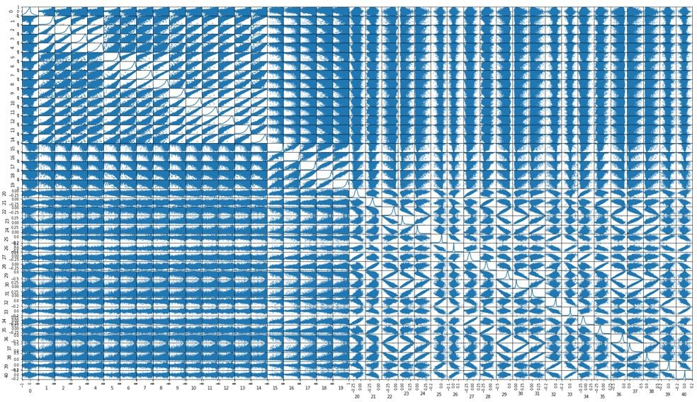

*Fig 1: Scatter Matrix for the features in the dataset*

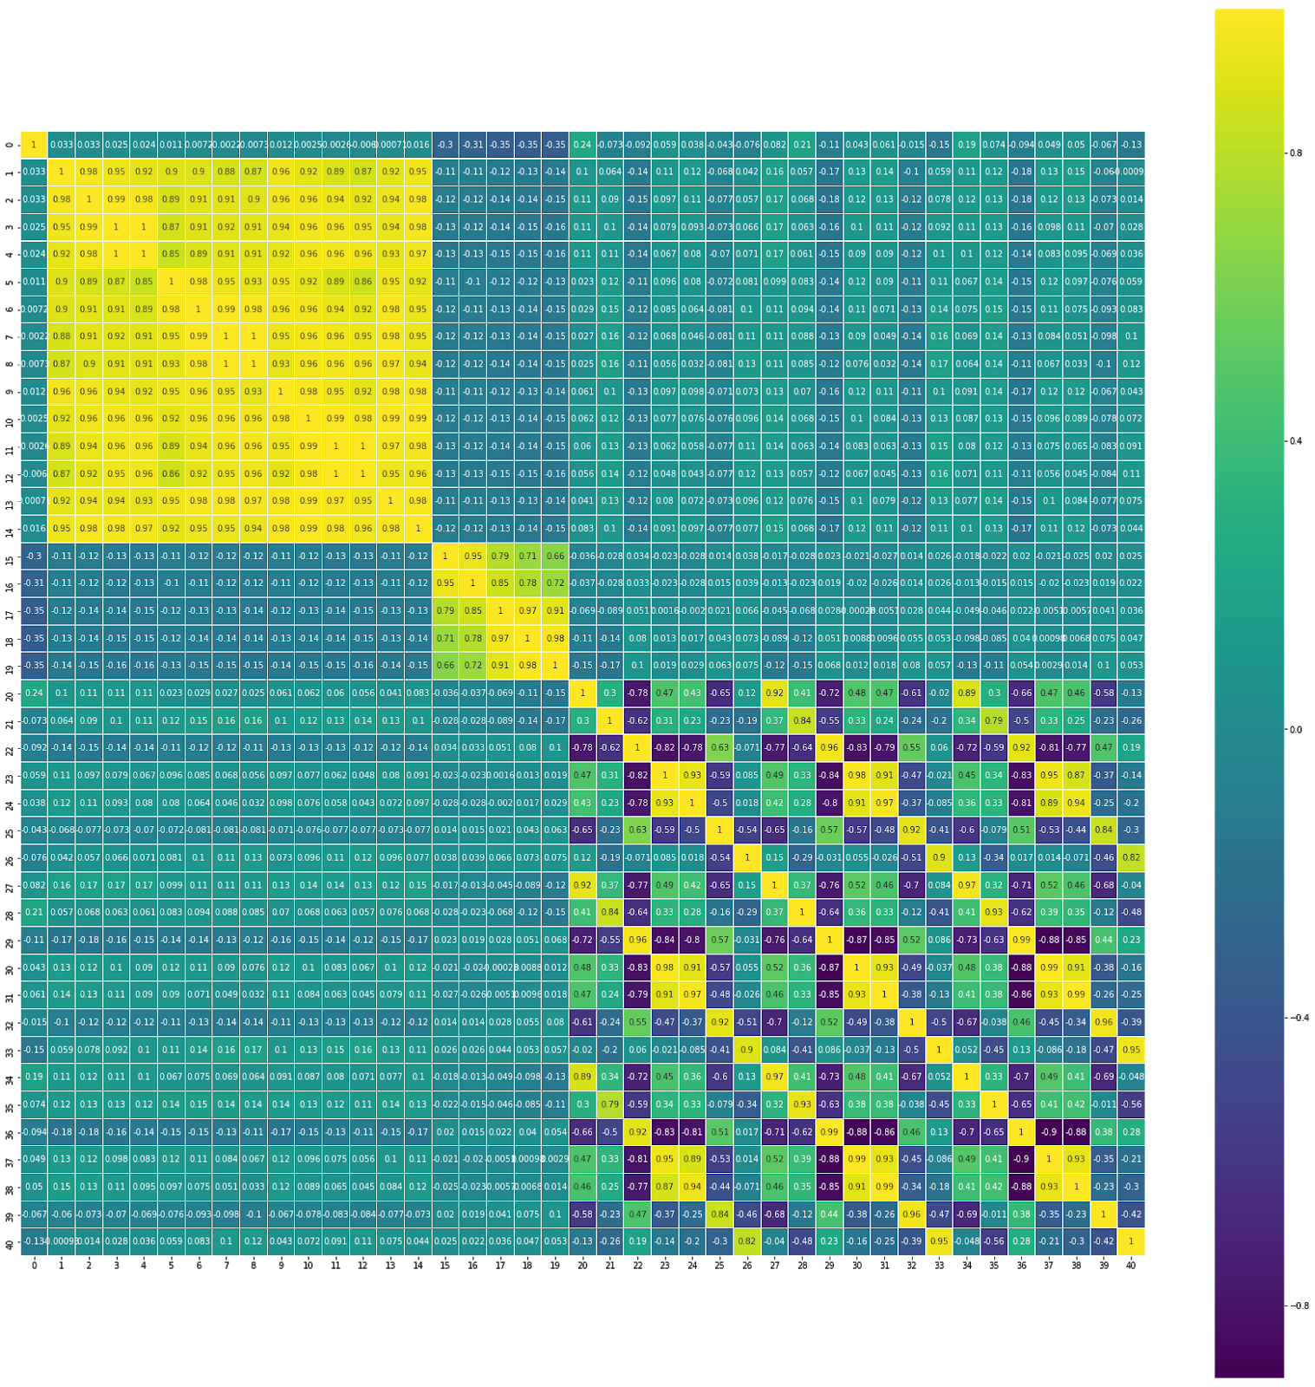

*Fig 2: Heatmap for the features in the dataset*

I noticed the presence of several strong correlations, both positive and negative from the above figures. This indicated the possibility of dimensionality reduction without a significant loss in information. I then went on to plot the kernel density estimation plots for each of the features in the dataset. The intention was to observe and transform in a non-linear fashion, any highly skewed feature. However, since none of the features were especially highly skewed, this step was not necessary.

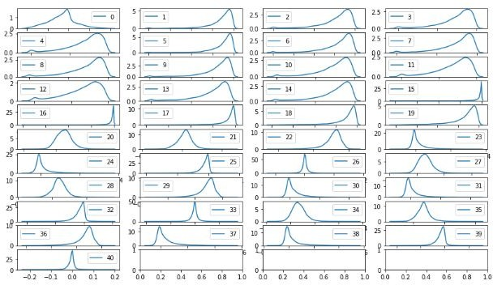

*Fig 3: Kernel Density Estimation Plots for the features in the dataset*

Outlier detection and removal is essential for high performance on several supervised as well as unsupervised techniques. I used the IQR rule for detection of outliers with respect to each feature. By this rule, an entry is considered an outlier with respect to a given feature if it lies outside the [Q1 – (1.5 * IQR): Q3 + (1.5 * IQR)] bracket, where Q1, Q3, and IQR are the first quartile, third quartile and inter quartile range respectively for the given feature. I then went on to remove all entries which were outliers with respect to more than 5 features.



*Fig 4: Kernel Density Estimation Plots for the features in the dataset after outlier removal*

Finally, I performed Principal Component Analysis on the data. Removal of outliers was essential before this step as PCA is highly sensitive to outliers. PCA performs a linear transformation of the feature space that results in a new feature space in which each axis is in the direction of maximum variance in the data. Hence, the first k principal components (features after the transformation) are guaranteed to capture the maximum variance in the data, as opposed to any other combination of k features in the new feature space. After PCA, the first 10 principal components captured 99.23% of the variance in the data. Hence, the original 41 dimensional was reduced to only 10 dimensions with a mere 0.77% loss in variance.

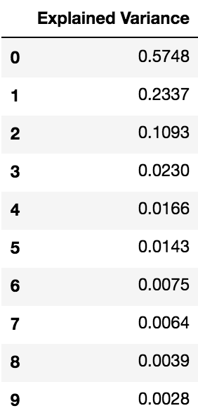

*Fig 5: Variance explained by the first 10 principal components*

**Implementation**

I have trained several classifiers on each of the original, cleaned and reduced datasets respectively. These classifiers include Gaussian Naïve Bayes, Random Forests, Support Vector Classifier, AdaBoost and a Multi-Layer Perceptron Neural Network. For each of the classifiers, I have noted the performance based on the train time, prediction time, train accuracy, test accuracy, train f-score and test f-score for different training sizes. I have also compared the accuracy and f-score with that of the Benchmark Gaussian Naïve Bayes Predictor on the original dataset. I found that all the classifiers except the MLP Classifier improved in performance when training on the cleaned dataset over the original dataset. The MLP Classifier f-score decreased by around 1%. When comparing training times, SVC takes the longest, followed by the MLP classifier and AdaBoost. However, in our case, we are willing to trade off training time in favour of better performance. SVC also has a significantly high testing time. This makes it sub optimal for our use case, as in the final model, extraction of CF features itself is time intensive, and hence we would like to save as much time as possible in the prediction component. For training on the reduced dataset, I found that the simpler models including Naive Bayes and SVC also work very well, when compared to the other models. Overall, I found that the MLP Classifier and AdaBoost consistently outperformed all the other classifiers in terms of test accuracy and test f-score. The visualizations of the results for the implementation stage are shown below. The dotted black lines in the plots indicate the benchmark scores.

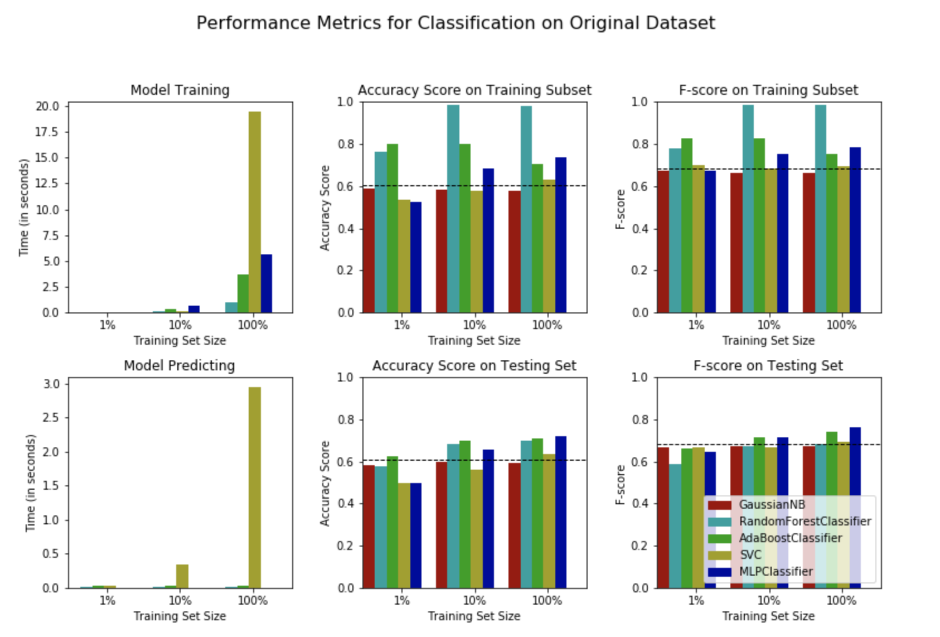

*Fig 6: Performance Graphs for Learning on the Original Dataset*

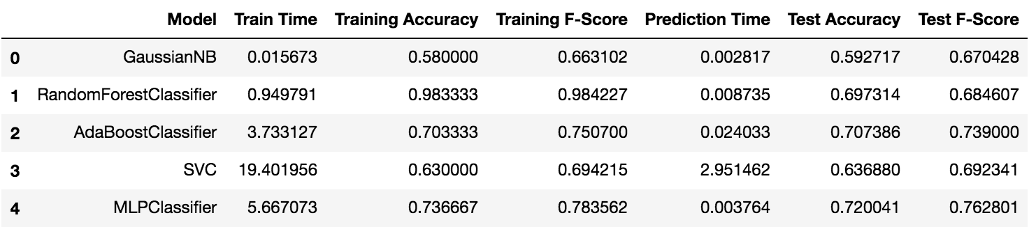

*Fig 7: Performance Table for Learning on the Original Dataset*

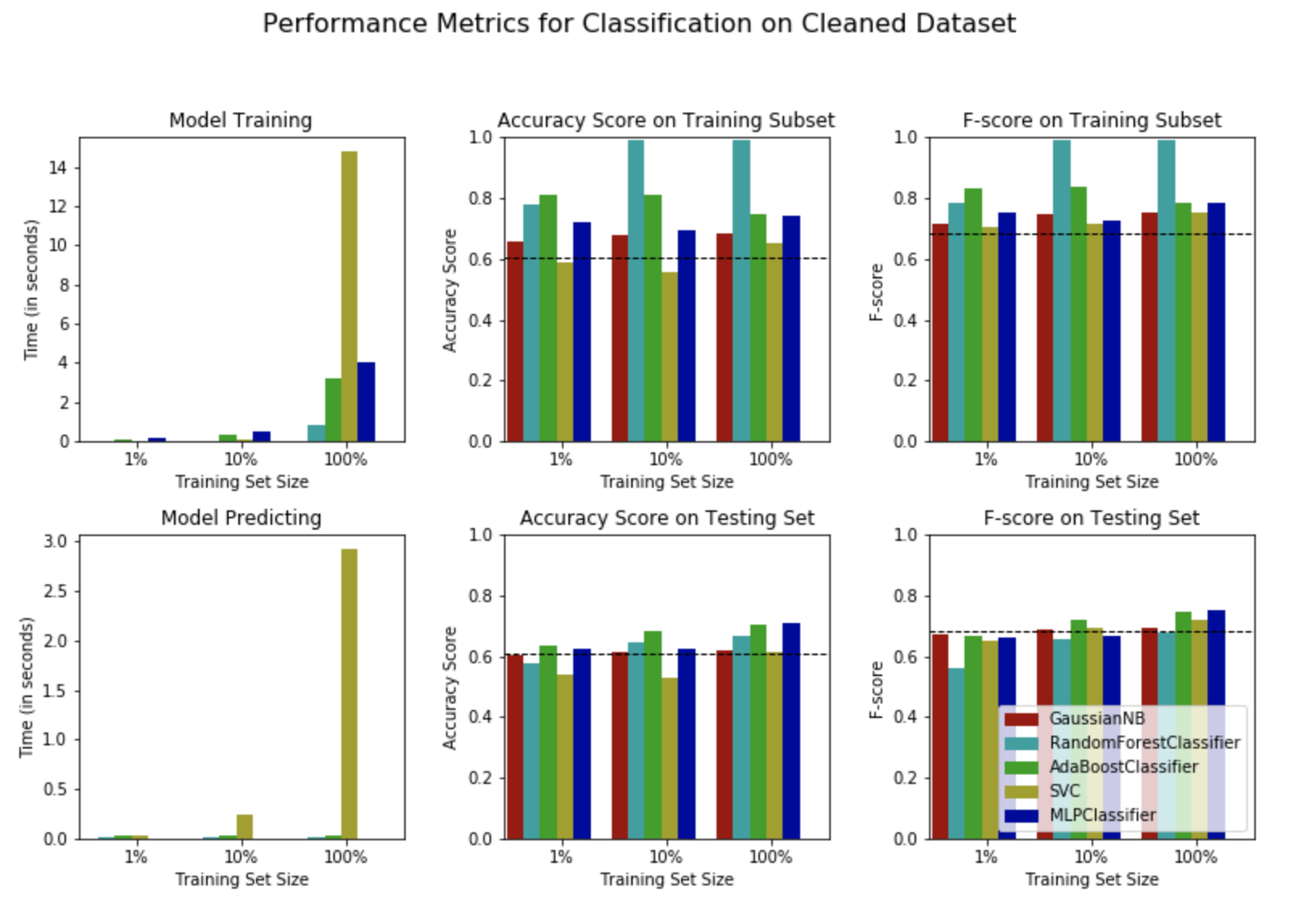

*Fig 8: Performance Graphs for Learning on the Cleaned Dataset*

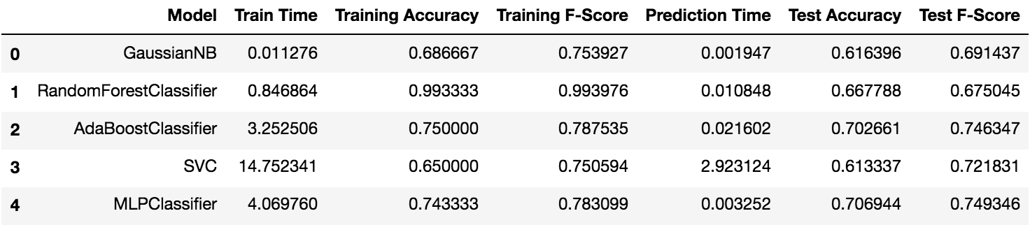

*Fig 9: Performance Table for Learning on the Cleaned Dataset*

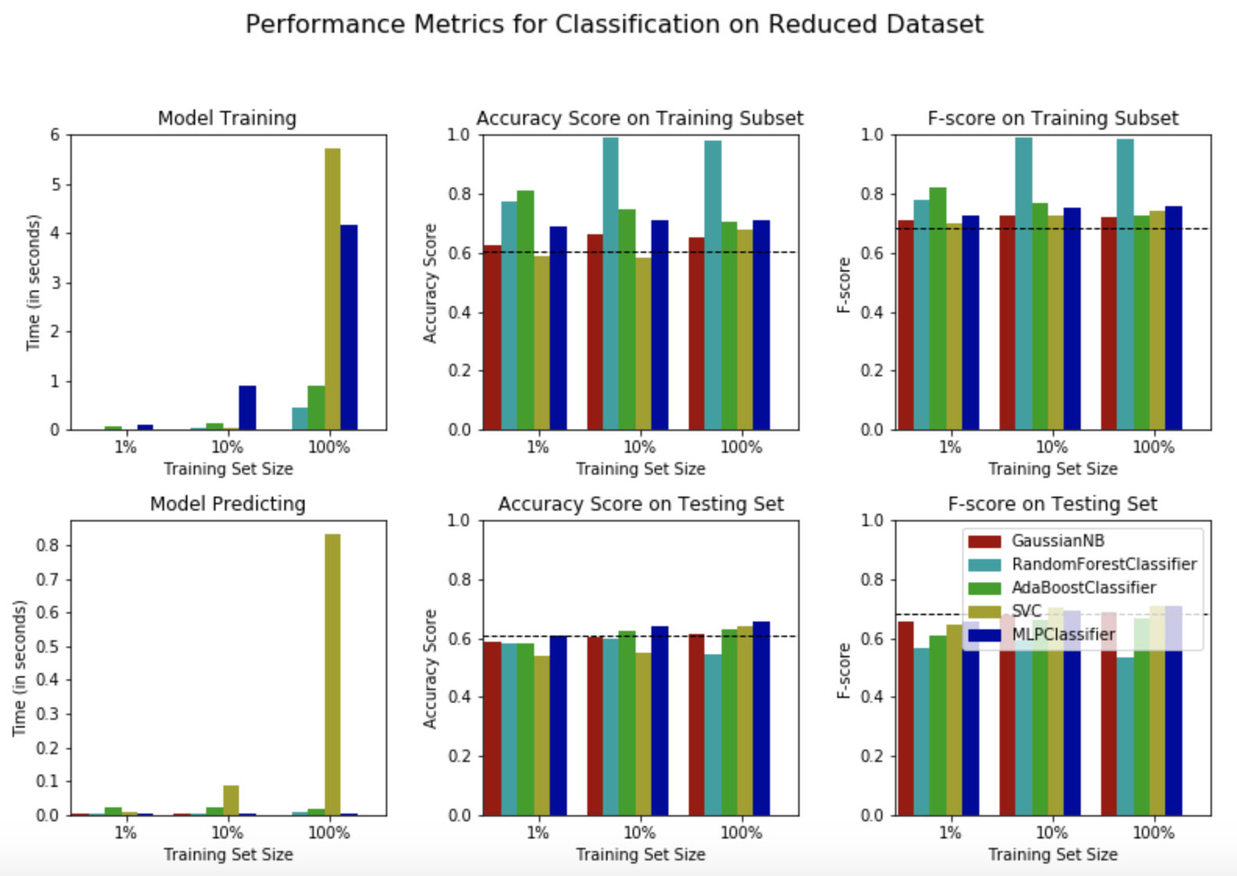

*Fig 10: Performance Graphs for Learning on the Reduced Dataset*

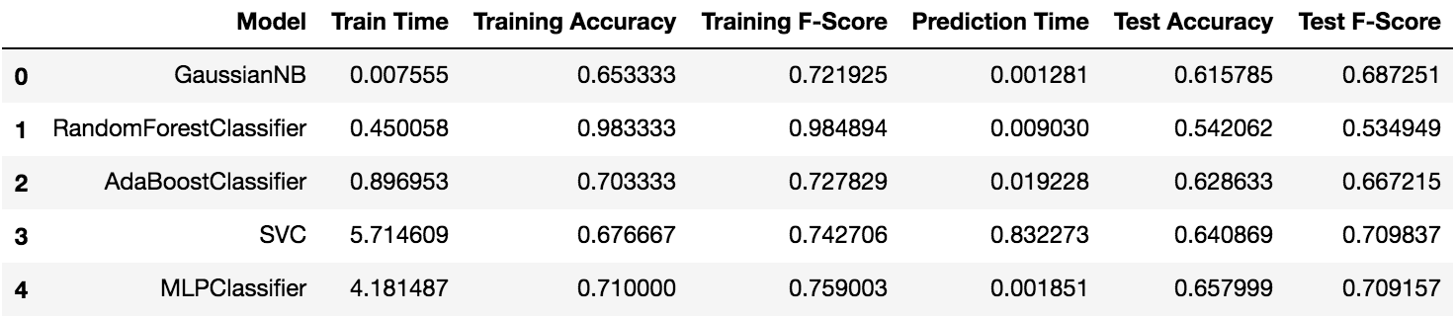

*Fig 11: Performance Table for Learning on the Reduced Dataset*

**Refinement**

Since the MLP Classifier and AdaBoost consistently outperformed all the other classifiers, I performed hyper parameter tuning on these classifiers using grid search. The AdaBoost classifier was tuned with respect to number of estimators and learning rate whereas the MLP Classifier was tuned with respect to its optimization tolerance and hidden layer structure. The tuned models for both the classifiers boasted improved performance (around 1% to 5% improvement in both accuracy and F-score). Finally, I exported the tuned models learned by the MLP Classifier and AdaBoost on the original and cleaned data. Thus, I had four high performing models which I used as voters in the ensemble voting based steganalysis prediction system. The final model is implemented in the 'steganalysis.py' file present in the 'Final Model' folder. It takes the path of an image as its command line argument and outputs a prediction as to whether or not the image is corrupted with LSB matching steganography. It is also worth mentioning that while the models trained on the reduced data were not as high performing, the comparatively smaller training time makes the reduced dataset ideal for training on larger datasets.

**IV. Results**

**Model Evaluation and Validation**

The final model is a majority voting ensemble of the parameter tuned versions of the 4 models that performed the best among all the models explored. These models are namely the models obtained by training of the MLP Classifier and the AdaBoost classifier on the original and cleaned datasets. The final model is implemented in the 'steganalysis.py' file present in the 'Final Model' folder. It takes the path of an image as its command line argument and outputs a prediction as to whether or not the image is corrupted with LSB matching steganography. To test the performance of the final model, I have also implemented an equivalent variant of the final model in ‘steganalysisfunc.py’, which has a function that takes the path of an image as the input parameter and returns the prediction of the voting ensemble. This allows me to import the file as a module in my notebook and call the function several times with different input images for computation of performance metrics.

To test the performance of the final model, I randomly sampled 1% of the original image dataset as the test set (100 cover images and 100 steg images). Each of these images were passed to the final model to return a prediction. The accuracy and F-score of the model were computed on these prediction values against the original values. Following are the results:

Accuracy of final model: 0.7552083333333334

F-Score of final model: 0.7929515418502202

The majority voting model is clearly better than any of its component parameter tuned models (quantitatively 1.59% better than the MLP Classifier on the original dataset, which is the best individual performer). Since none of the components in the ensemble have significantly high prediction times, I feel that it is justified to use this voting approach.

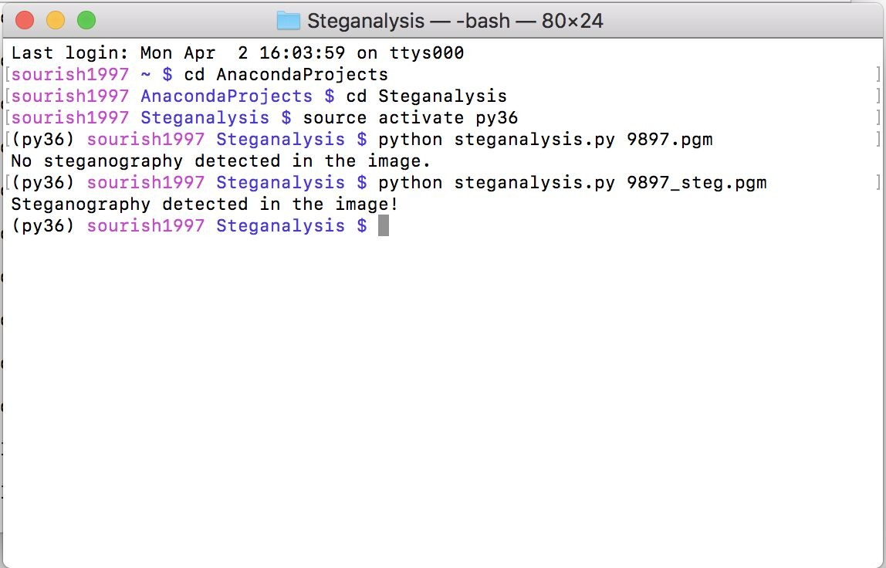

*Fig 12: Sample Output of the Final LSB Matching Detection Tool*

It is also worthwhile to analyse some of the shortcomings of the final model. One of the major drawbacks is a direct consequence of the feature set chosen. The correlation features are defined in a way that might lead to NaN values in the case of overly dark or overly bright images. I had to remove rows corresponding to such images in the pre-processing stage. Consequently, steganalysis of such images cannot be performed by the final model, since the underlying parameter tuned models cannot accept NaN feature values as input. Another drawback is that the feature extraction process has only been defined for 512x512 greyscale images. If an image of some other dimension needs to be input, it has to be either cropped or resampled for the current model. Such transformations may alter the spatial data of the image, and consequently affect the predicting power of the model. Candidate solutions to these problems have been discussed under the ‘Improvement’ section.

**Justification**

Following are the accuracy and F-score values for the benchmark and the final model:

Accuracy of Benchmark: 0.6059

Accuracy of Final Model: 0.7552

F-Score of Benchmark: 0.6819

F-Score of Final Model: 0.7930

Clearly, the final model is far superior to the Gaussian Naïve Bayes benchmark model. It is also superior when compared to the performance metrics of the final model presented in [5] for steganalysis of LSB matching in greyscale images. To train their model, they have used an image dataset in which the steg images are corrupted with a payload of 0.5; that is half of the pixels in the image are modified due to the steganography process. They report an accuracy score of around 0.7 for the final model on the least complex image set. Generally, with decrease in payload, the classification task becomes more difficult, because less pixels are touched due to the steganography process, and consequently less information to learn. However, my final model gives significantly superior results despite being trained on a dataset of images with a lower payload (0.4) for the steg images. Because of these reasons, I feel that the final model does a good job at solving the proposed classification task.

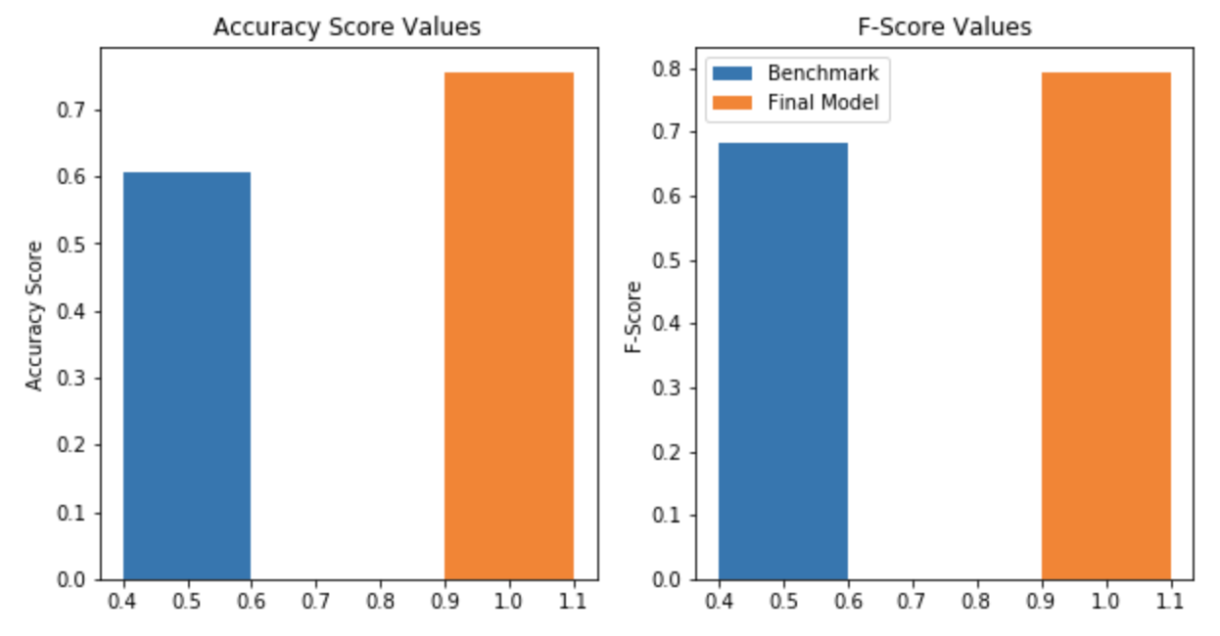

*Fig 13. Comparison of Performance Metrics between Benchmark and Final Model*

**V. Conclusion**

**Free-Form Visualization**

In this section, I would like to discuss an important property of the steg images in the dataset that warrant the use of machine learning techniques for steganalysis in the first place. I would first like to briefly go over LSB replacement steganography, and why it is relatively easy to detect it with statistical methods alone. LSB replacement keeps the LSB bit unchanged if it is same as the message bit, and alters it otherwise. Hence, the odd pixels are reduced by 1 in intensity, whereas the even pixel values are incremented by 1. This naïve form of bit replacement causes an imbalance in the histogram, resulting in frequent spikes in the histogram. It produces ‘Pairs

of Values’ on the intensity histogram of the steg images. This is clearly demonstrated in the visualization below.

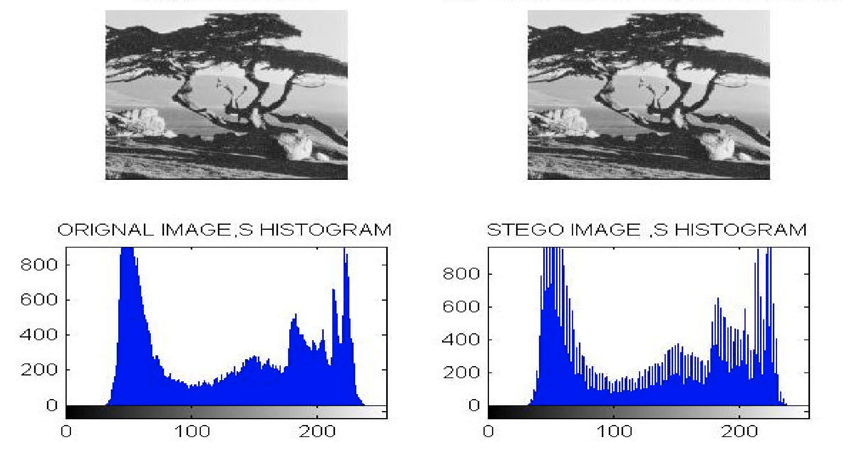

*Fig 14. Comparison of Histograms of Image Both Before and After LSB Replacement [7]*

Since LSB replacement is inherently asymmetric, statistical steganalysis methods can detect it easily. LSB matching is a modified version of LSB replacement. Instead of simply replacing the LSB of the cover image, it randomly either adds or subtracts 1 from the cover image pixel value that has mismatched LSB with the secret message bit. This random ±1 change to the mismatched LSB pixel values avoids the asymmetry changes to the cover image, which is the case with LSB replacement. Hence, LSB matching is considered harder to detect than LSB replacement, and machine learning techniques are frequently used for this purpose.

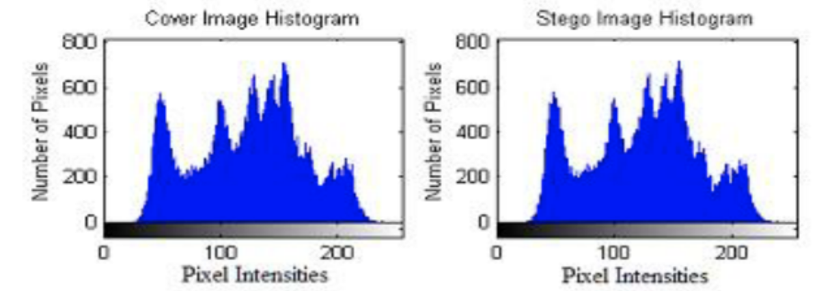  
*Fig 15. Comparison of Histograms of Image Both Before and After LSB Matching*

**Reflection**

I have used a labelled dataset of greyscale images, both with and without LSB matching steganography, and have developed a majority voting based tool comprised of parameter tuned powerful models for predicting presence or absence of LSB matching in an image. The development process involved extraction of CF features from the images in the raw dataset, pre-processing techniques including cleaning, removal of outliers, dimensionality reduction via PCA, training of several classifiers, hyper parameter tuning of the learners corresponding to the best models obtained, and finally construction of the voting ensemble.

I found the domain relevant reading prior to implementing the project particularly interesting. Learning about the different types of steganography and steganalysis methods and techniques including HCFCOM, HOMMS, etc., both statistical and ML based was a challenging but fun exercise. A particularly time intensive procedure was the extraction of correlation features from the images in the raw dataset. Implementation of the feature extraction section was also an interesting exercise.

**Improvement**

As discussed under the results section, steganalysis of very bright/dark images cannot be performed by the final model, since the underlying parameter tuned models in the voting ensemble cannot accept NaN feature values in the corresponding CF features as input. One way to solve this problem is to substitute the NaN values by statistical approximations like the mean or median of the corresponding attributes. A more intelligent approach would be to use a simple learner like Gaussian Naïve Bayes to approximate the NaN values given the other correlation feature values for the image. The modified feature set thus obtained can then be passed to the final model for prediction. Alternatively, an alternate solution may be used to handle the special case of very bright/dark images. Typically, such images are not very good candidates for steganography as the modified pixels stand out in a significantly clearer manner against the more uniform color canvas. Statistical methods might be used to exploit these anomalous situations.

One other drawback is that the feature extraction process has only been defined for 512x512 greyscale images. If an image of some other dimension needs to be input, it has to be either cropped or resampled for the current model. Such transformations may alter the spatial data of the image, and consequently affect the predicting power of the model. Notably, cropping an image does not alter the spatial data in an image; rather it leads to loss of a part of the spatial data. For large images, therefore, an accurate prediction can be made by using the final model to make predictions on several 512x512 crops of the image from different regions and taking the majority vote of the predictions. The simplest solution however would be to generalize the feature extraction process to work for images of all sizes. This would make the final model work well for small images as well, which is currently not possible, even with workarounds like in the case of large images.

Besides ways to overcome the above explored drawbacks, the final model can also probably be improved by using more powerful learners like LightGBM and XGBoost.

**VI. References**

[1] Khalind, Omed, and Benjamin Yowell Yousif Aziz. "LSB Steganography with Improved Embedding Efficiency and Undetectability". Computer Science & Information Technology 5.1 (2015): 89-105.

[2] J. Harmsen and W. Pearlman, “Steganalysis of Additive Noise Modelable Information Hiding”, Proceedings of SPIE, vol. 5020, pp. 131–142, 2003.

[3] A. Ker: “Steganalysis of LSB Matching in Grayscale Images”, IEEE Signal Processing Letters, 12(6), pp. 441–444, 2005.

[4] S. Lyu and H. Farid, “How Realistic is Photorealistic”, IEEE Trans. on Signal Processing, 53(2), pp. 845-850, 2005.

[5] Liu Q, Sung AH, Xu J, Ribeiro BM. “Image Complexity and Feature Extraction for Steganalysis of LSB Matching Steganography”. In Pattern Recognition, 2006. ICPR 2006. 18th International Conference on 2006 Aug 20 (Vol. 2, pp. 267-270). IEEE.

[6] [Aletheia – Open Source Image Steganalysis Tool](https://github.com/daniellerch/aletheia)

[7] Kamaldeep Joshi, Rajkumar Yadav, Sachin Allwadhi, “Exploration of Least Significant Bit Based Watermarking and Its Robustness against Salt and Pepper Noise”. International Journal of Computer, Electrical, Automation, Control and Information Engineering Vol:10, No:7, 2016